**Que. 1**

**Query the average population for all cities in CITY, rounded *down* to the nearest integer.**

**Input Format**

**The CITY table is described as follows:**

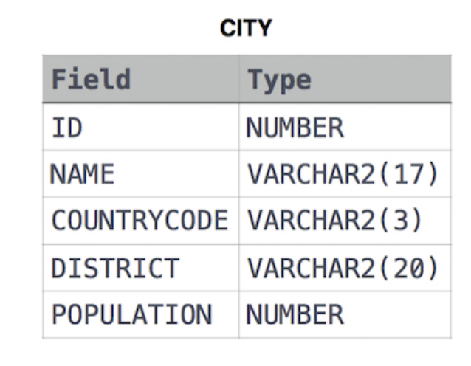

**Solution:**

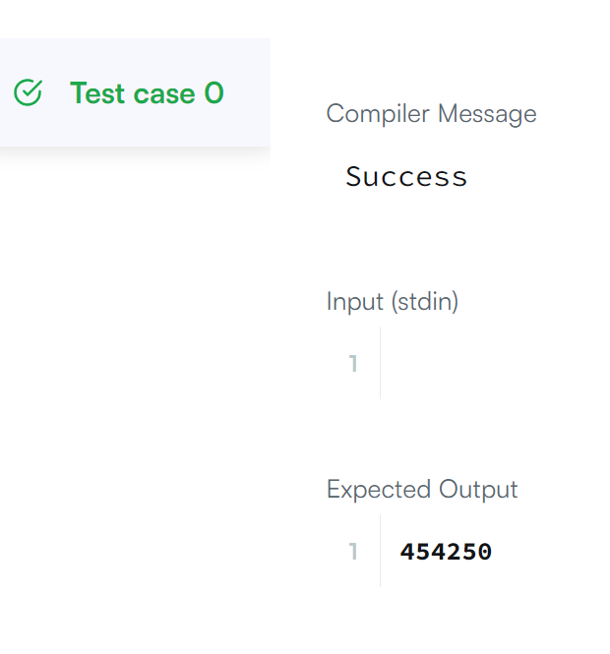

**Que. 2**

**Query the sum of the populations for all Japanese cities in CITY. The *COUNTRYCODE* for Japan is JPN.**

**Input Format**

**The CITY table is described as follows:**



**Solution:**

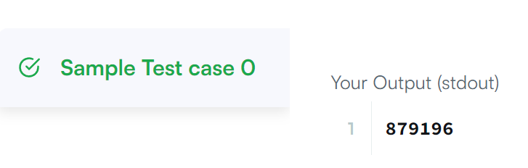

**Que.3**

**Query the difference between the maximum and minimum populations in CITY.**

**Input Format**

**The CITY table is described as follows:**

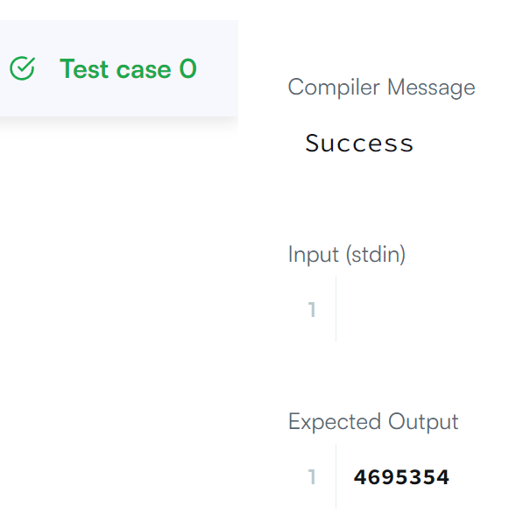Solution:

**Que.4**

**Query the following two values from the STATION table:**

1. **The sum of all values in *LAT_N* rounded to a scale of 2 decimal places.**
2. **The sum of all values in *LONG_W* rounded to a scale of 2 decimal places.**

**Input Format**

**The STATION table is described as follows:**

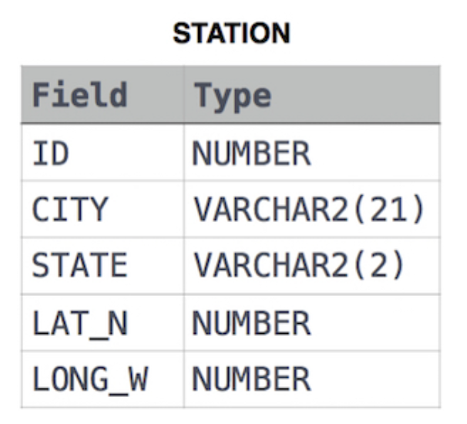

**Solution:**

